

Assessment Cover Page
Student Full Name
Nicolas Cancino Ortega
Student Number
2026623
Module Title
Strategic Thinking
Assessment Title
CA 1 – Capstone Project Proposal
Lecturer/Supervisor
Taufique Ahmed
Assessment Due Date 25/10/2026
Date of Submission
25/10/2026

Demographic Patterns and Health Impacts of Air Pollution in New York City: A Data Analytics Approach

Introduction
One of the major problems of our time is air pollution, particularly in highly urbanised cities, where it has been associated with cardiorespiratory diseases and even cancer. Numerous pollutants contribute to the development of these conditions in humans, particularly particulate matter (PM), which can penetrate the respiratory system. Using air pollution measurements from New York City, provided by the Department of Health and Mental Hygiene (DOHMH), this project aims to geographically identify areas of New York with higher levels of air pollution through data analysis and explore how these levels may be associated with a higher prevalence of cardiorespiratory diseases among the exposed population.

Problem Definition
The main problem we face is air pollution and how it can affect the health of people living in the most populous city in the United States. Therefore, by using the available data to examine how air pollution is distributed geographically and across different periods of time, it is possible to identify which areas of New York City may be more affected. This could indicate where environmental monitoring should be strengthened, where more healthcare resources should be allocated for preventive and reactive measures, and where public awareness should be promoted. It could also support future research aimed at improving the quality of life of the city's residents.

Aim and Objectives

Aim
The aim of this project is to investigate the geographical and temporal variations in air pollution across New York City and generate data-driven insights that could help environmental and public health authorities identify areas requiring greater environmental and health monitoring. It also aims to support future studies and provide information to the public.

Objectives
- Data Preparation: To analyse the data using Jupyter Notebook, clean and prepare the dataset by identifying missing or incomplete values, analysing variable types, and exploring relationships between variables to facilitate their interpretation and ensure their suitability for the main project objective.
- Exploratory data analysis: To identify geographical and temporal patterns in the concentrations of environmental pollutants, particularly PM2.5 and others, across different areas of New York City using the prepared dataset, statistical analysis, and data visualisation tools.
- Predictive Modelling: To develop a linear regression model to predict concentrations of PM2.5 and other pollutants across different geographical areas and over time, using the historical data available in the dataset.
- Public Health Insights: To investigate the association between concentrations of PM2.5 and other air pollutants and their relationship with the incidence of cardiorespiratory diseases, with the aim of making data-driven recommendations.

Business Objective
The analysis of this data allows us primarily to identify areas that may require stricter environmental and public health monitoring. This enables authorities to better prepare for potential risks to the population, highlighting the importance of prevention and action in avoiding a purely reactive healthcare policy that only responds when a disease emerges. Such an approach may result in higher costs for the hospital system compared to a proactive policy that anticipates problems and helps reduce healthcare costs.

Scope

Included
- Study of the geographical and temporal distribution of PM2.5.
- Supplementary comparison with other pollutants, such as NO₂ and ozone, where comparable measurements are available.
- Exploration of associations between air pollution and available respiratory and cardiovascular health indicators.
- Development and evaluation of predictive models to estimate PM2.5 levels.
- Visualisations and recommendations aimed at environmental monitoring and public health.

Excluded
- Diagnosing diseases in individual patients.
- Demonstrating a direct causal relationship between pollution and disease.
- Developing a real-time monitoring application or installing our own sensors.
- Predicting future individual diseases or clinical outcomes with certainty.
- Analysing all possible pollutants and diseases without a specific justification.

Methodology
Data Sources
The main data source for this project will be the Air Quality and Health Impacts dataset, published on NYC Open Data by the New York City Department of Health and Mental Hygiene (DOHMH). The dataset contains approximately 19,827 records and 12 columns, including aggregated air quality and health indicators across different geographical areas and time periods (NYC Open Data, 2026).
According to the dataset's data dictionary, the information includes unique record identifiers, indicator identifiers and names, measurement types and units, geographical types and identifiers, neighbourhood names, time-period descriptions, start dates, recorded values and notes (NYC Open Data, 2026). These variables will help identify the type of measurement, where and when it was recorded, and the value associated with each observation. Geographical identifiers may also support the creation of thematic maps by linking the data to appropriate geographical files.
The dataset is publicly accessible through the NYC Open Data portal and can be downloaded in CSV format. The project will use this publicly available information for academic analysis, with appropriate acknowledgement of the original source and consideration of the applicable terms of use (NYC Open Data, n.d.).
In addition, the dataset page provides links to other resources that may support further analysis. These include the Real-Time Air Quality in NYC portal, which provides hourly PM2.5 measurements (NYC Department of Health and Mental Hygiene, n.d.-a), and the Health Impacts of Air Pollution Data Explorer, which provides information on health outcomes associated with air pollution (NYC Department of Health and Mental Hygiene, n.d.-b). These sources may be considered for further comparisons or to explore more specific relationships between pollution levels and health indicators, subject to data compatibility and project requirements.
The dataset is provided by the New York City Department of Health and Mental Hygiene (NYC DOHMH) and contains aggregated air quality and health indicators. It is publicly available through NYC Open Data. Its use will comply with the portal's terms of use (NYC Open Data, n.d.), and the original source will be acknowledged. The dataset's limitations and indicator-specific methodologies will also be considered when interpreting the results (NYC Open Data, 2026).
References
NYC Open Data (2026) Air Quality and Health Impacts: Data Dictionary. Available at: https://data.cityofnewyork.us/Environment/Air-Quality-and-Health-Impacts/c3uy-2p5r (Accessed: 19 October 2026).

NYC Open Data (n.d.) Terms of Use. Available at: https://data.cityofnewyork.us/stories/s/Terms-of-Use/k9k7-3cje (Accessed: 19 October 2026).

NYC Department of Health and Mental Hygiene (n.d.-a) Real-Time Air Quality in NYC. Available at: https://a816-dohbesp.nyc.gov/IndicatorPublic/data-features/realtime-air-quality/ (Accessed: 19 October 2026).

NYC Department of Health and Mental Hygiene (n.d.-b) Health Impacts of Air Pollution Data Explorer. Available at: https://a816-dohbesp.nyc.gov/IndicatorPublic/data-explorer/health-impacts-of-air-pollution/?id=2121&MeasureID=652&GeoType=UHF42&TimePeriodID=282&overlay=table (Accessed: 19 October 2026).

Expected Deliverables
By the end of Semester 2, the project is expected to produce the following deliverables:
- Predictive Modelling: Develop and evaluate suitable machine learning models to predict PM2.5 concentrations using historical data and relevant geographical and temporal variables. The models will be evaluated to identify the most accurate and reliable approach and, where the available data allow, tested with new data to assess their performance over time.
- Comparison with Additional Datasets: Identify and compare relevant datasets available through NYC Open Data to investigate relationships between air pollution and aggregated health indicators. This will help provide a broader evidence base for understanding potential associations, subject to data compatibility and availability.
- Evidence-Based Recommendations: Prepare a final report presenting the methodology, data preparation process, model performance, key findings, and limitations. Based on the results, the report will provide evidence-based recommendations to help environmental and public health authorities identify areas that may require further monitoring or investigation.
- Project Reproducibility: Create and maintain a GitHub repository containing the Python code, documentation, data processing procedures, and relevant analytical results. This will promote transparency and allow the analytical workflow to be reviewed and reproduced, subject to the applicable data usage conditions.

Project Timeline
The project will be carried out over two semesters. The first semester will focus on understanding, preparing, and exploring the selected dataset, while the second semester will focus on developing predictive models, comparing additional datasets, evaluating the results, and preparing the final recommendations.
The timeline may be adjusted depending on data availability and project progress, which will be more clearly represented th
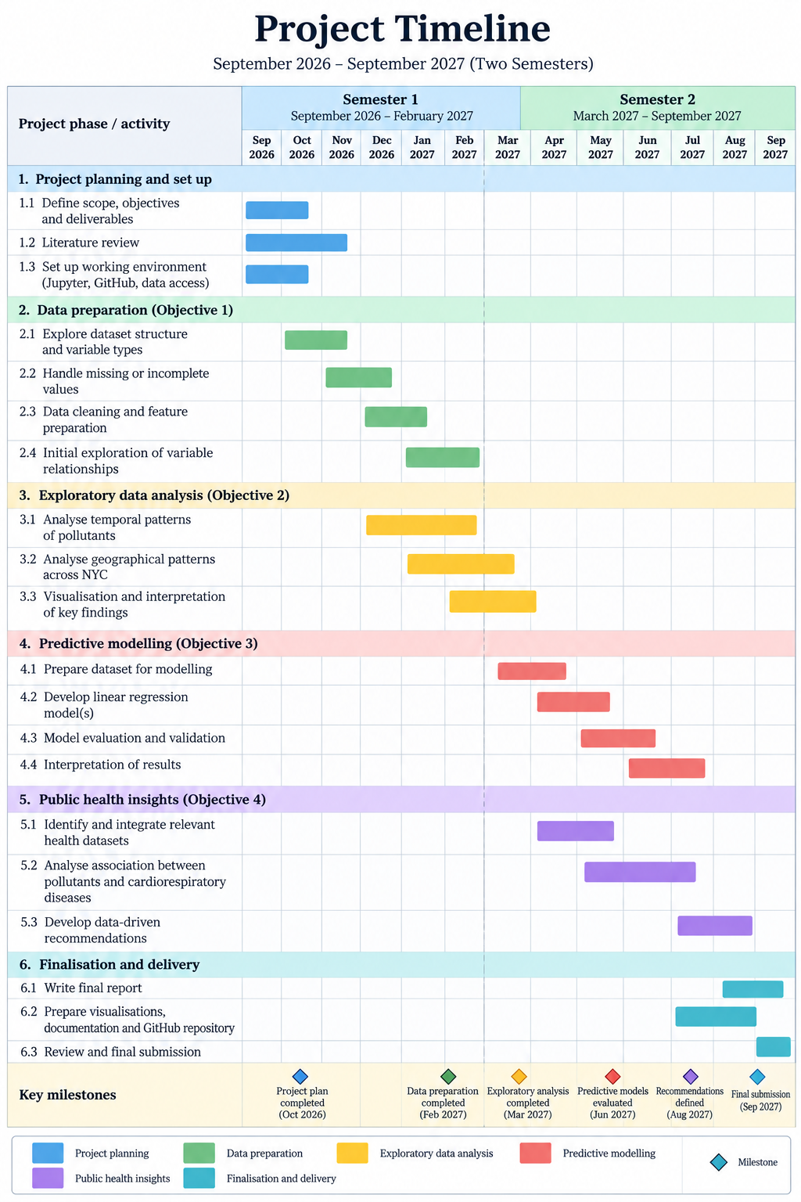

Ethical and Legal Considerations
This project will use publicly available datasets from NYC Open Data, complying with the applicable Terms of Use and acknowledging all sources. As the selected dataset contains aggregated environmental and health indicators rather than individual patient records, privacy risks are limited. Project files will be managed securely, and the GitHub repository will contain code and documentation without confidential information. The results will be interpreted responsibly, avoiding causal claims and acknowledging data limitations and potential biases.

